CHAPTER-6

Physical Layer

6.1 Introduction
The physical layer is the bottom-most layer of Internet model that actually interacts with the transmission media, the physical part of the network that connects network components together. This layer is involved in physically carrying information from one node in the network to the next. The physical layer has complex tasks to perform. One major task is to provide services for the data link layer. The data in the data link layer consists of 0s and 1s organized into frames that are ready to be sent across the transmission medium. This stream of 0s and 1s must first be converted into another entity: signals. One of the services provided by the physical layer is to create a signal that represents this stream of bits. The physical layer must also take care of the physical network, the transmission medium. The transmission medium is a passive entity; it has no internal program or logic for control like other layers. The transmission medium must be controlled by the physical layer. The physical layer decides on the directions of data flow.

6.2 Transmission media
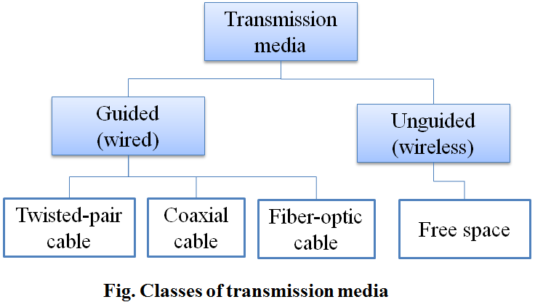
A transmission medium can be broadly defined as anything that can carry information from a source to a destination. Transmission media are actually located below the physical layer and are directly controlled by the physical layer. You could say that transmission media belong to layer zero.

The transmission media that are used to convey information can be classified as guided or unguided. Guided media provide a physical path along which the signals are propagated; these include twisted pair, coaxial cable, and optical fiber. Unguided media employ an antenna for transmitting through air, vacuum, or water.

The characteristics and quality of a data transmission are determined both by the characteristics of the medium and the characteristics of the signal. In the case of guided media, the medium itself is more important in determining the limitations of transmission.

6.1.1 Guided Transmission Media
Guided media include twisted-pair cable, coaxial cable, and fiber-optic cable, that provide a direct connection from one device to another. A signal traveling along any of these media is directed and contained by the physical limits of the medium. Twisted-pair and coaxial cable use metallic (copper) conductors that accept and transport signals in the form of electric current. Optical fiber is a cable that accepts and transports signals in the form of light. The data rate and distance in transmission are mainly depends upon the bandwidth, interference, number of receivers and the transmission impairments. Twisted pair generally suffers more impairment (attenuation) than coaxial cable, which in turn suffers more than optical fiber.

- Twisted Pair Cable
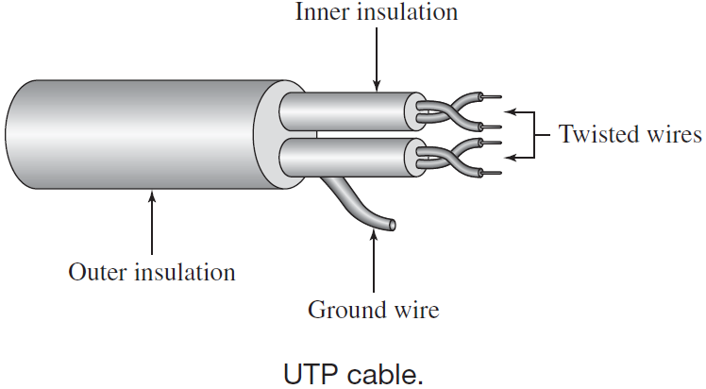
A twisted pair consists of two insulated copper wires arranged in a regular spiral pattern and covered with a foil or braid shield. A wire pair acts as a single communication link. Typically, a number of these pairs are bundled together into a cable by wrapping them in a tough protective sheath. Over longer distances, cables may contain hundreds of pairs. The twisting tends to decrease the crosstalk interference between adjacent pairs in a cable. If the two wires are parallel, the effect of these unwanted signals is not the same in both wires because they are at different locations relative to the noise or crosstalk sources. This results in a difference at the receiver. By twisting the pairs, a balance is maintained.

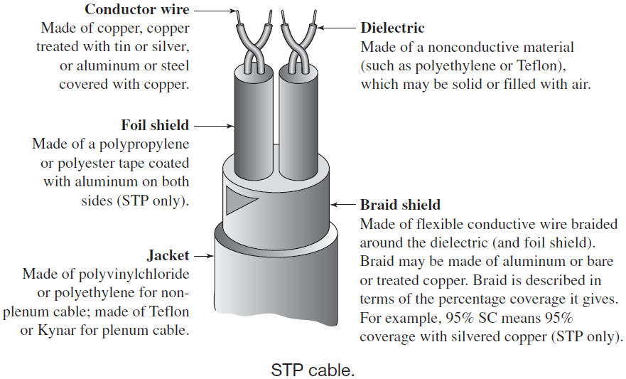

The most common twisted-pair cable used in communications is referred to as unshielded twisted-pair (UTP). IBM has also produced a version of twisted-pair cable for its use called shielded twisted-pair (STP). STP cable has a metal foil or braided mesh covering that encases each pair of insulated conductors. Although metal casing improves the quality of cable by preventing the penetration of noise or crosstalk, it is bulkier and more expensive. Figure shows the difference between UTP and STP. Our discussion focuses primarily on UTP because STP is seldom used outside of IBM.

In 1991, the Electronic Industries Association, EIA-568-A recognizes three categories of UTP cabling:
- Category 3: UTP cables and associated connecting hardware whose transmission characteristics are specified up to 16 MHz
- Category 4: UTP cables and associated connecting hardware whose transmission characteristics are specified up to 20 MHz
- Category 5: UTP cables and associated connecting hardware whose transmission characteristics are specified up to 100 MHz

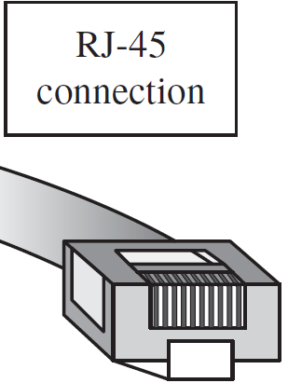
To connect the twisted pair cable to devices, the most common UTP connector is RJ45 (RJ stands for registered jack). Twisted-pair cables are used in telephone lines to provide voice and data channels.

- Co-axial Cable
Coaxial cable (coax) is a type of Ethernet media consisting of a single copper conductor surrounded by insulation (called a dielectric), a foil shielding, an outer jacket of PVC (a plastic for cable insulation), or plenum (Teflon-based fire-retardant cable insulation).
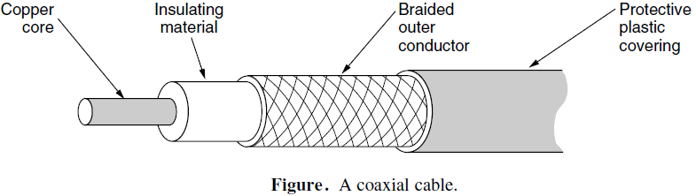

All coax cables share the same basic structure, but vary in the size of the central copper core and cable impedance, measured in ohms. Higher impedance means higher resistance to a changing current, which is what you have in a data signal. Higher resistance means greater signal loss over a distance.

Coaxial cables are categorized by their radio government (RG) ratings. Each RG number denotes a unique set of physical specifications, including the wire gauge of the inner conductor, the thickness and type of the inner insulator, the construction of the shield, and the size and type of the outer casing. Each cable defined by an RG rating is adapted for a specialized function, as shown in following table.
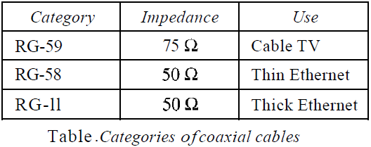
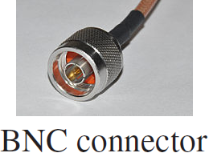

To connect coaxial cable to devices, we need coaxial connectors. The most common type of connector used today is the Bayone-Neill-Concelman (BNC), connector. Coaxial cable was widely used in analog telephone networks where a single coaxial network could carry 10,000 voice signals. Other main application of coaxial cable are: Television distribution, Long-distance telephone transmission, Short-run computer system links, and Local area networks.

Baseband vs. broadband coaxial cable
Baseband coaxial cable | Broadband coaxial cable
- It is a 50Ω cable used for digital transmission. | - It is a 75Ω cable used for analog transmission.
- The data rate lies in the range of 1KHz to 20MHz over a distance in the range of 1KM. | - The data rate of about 150Mbps and hence facilities high speed data communication with low bit error rate.
- Propagation of data in both directions. | - Signal propagation only in one direction.
- Mostly used in LAN | - Used in cable TV (CATV) & cable modems with data rate nearly equal to 10Mbps
- The repeater must be in every 1KM or closer for higher data rates. | - The amplifier must be in every few kilometers or closer for higher frequency up to 500MHz.
- Typically have a diameter of 3/8 inch | - CATV cable have ½ inch diameter for the distribution of TV signal.

- Using Fiber Optic
A fiber-optic cable is a thin (2 to 125 µm) flexible medium capable of guiding an optical ray.is made of glass or plastic and transmits signals in the form of light. It is designed to pass specific types of light waves over long distances with very little attenuation, the term for signal loss over distance. The center core of a multimode fiber-optic cable has a diameter of 125 microns (125μ), and is approximately the size of two human hairs. Fiber-optic cables can be purchased as single fibers or as pairs of up to 36 fiber strands. Pairs of fiber are needed to complete a full-duplex circuit.
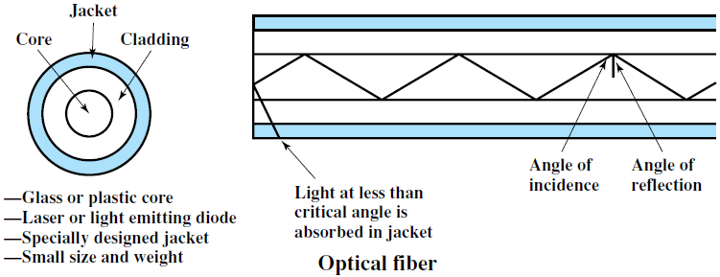

An optical fiber cable has a cylindrical shape and consists of three concentric sections: the core, the cladding, and the jacket. The core is the innermost section and consists of one or more very thin strands, or fibers, made of glass or plastic; the core has a diameter in the range of 8 to 50 µm. Each fiber is surrounded by its own cladding, a glass or plastic coating that has optical properties different from those of the core and a diameter of 125 µm. The interface between the core and cladding acts as a reflector to confine light that would otherwise escape the core. The outermost layer, surrounding one or a bundle of cladded fibers, is the jacket. The jacket is composed of plastic and other material layered to protect against moisture, abrasion, crushing, and other environmental dangers.

Optical fibers use total internal reflection of light to guide the light through a channel. A glass or plastic core is surrounded by a cladding of less dense glass or plastic. The difference in density of the two materials must be such that a beam of light moving through the core is reflected off the cladding instead of being refracted into it.

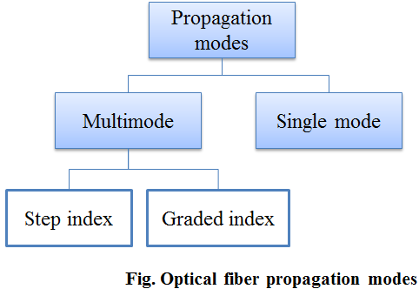
Propagation Modes
Current technology supports two modes (multimode and single mode) for propagating light along optical channels, each requiring fiber with different physical characteristics. Multimode can be implemented in two forms: step-index or graded-index

- Multimode: Multimode is so named because multiple beams from a light source move through the core in different paths. How these beams move within the cable depends on the structure of the core,
  - In multimode step-index fiber, the density of the core remains constant from the center to the edges. A beam of light moves through this constant density in a straight line until it reaches the interface of the core and the cladding. At the interface, there is an abrupt change due to a lower density; this alters the angle of the beam's motion. The term step index refers to the suddenness of this change, which contributes to the distortion of the signal as it passes through the fiber.
  - A second type of fiber, called multimode graded-index fiber, decreases this distortion of the signal through the cable. The word index here refers to the index of refraction. As we saw above, the index of refraction is related to density. A graded-index fiber, therefore, is one with varying densities. Density is highest at the center of the core and decreases gradually to its lowest at the edge.
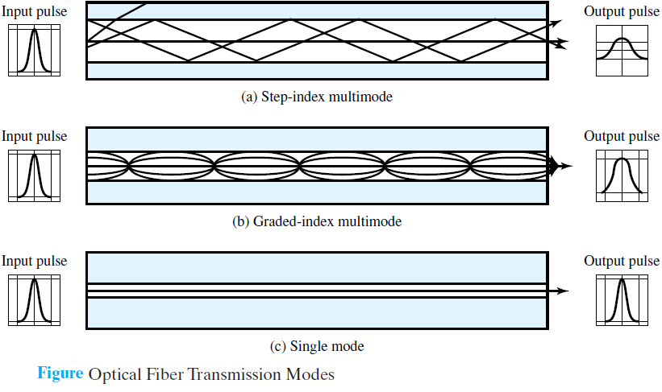

- Single-Mode: Single-mode uses step-index fiber and a highly focused source of light that limits beams to a small range of angles, all close to the horizontal. The single mode fiber itself is manufactured with a much smaller diameter than that of multimode fiber, and with substantially lowers density (index of refraction). The decrease in density results in a critical angle that is close enough to 90° to make the propagation of beams almost horizontal. In this case, propagation of different beams is almost identical, and delays are negligible. All the beams arrive at the destination "together" and can be recombined with little distortion to the signal

Connectors
There are three types of connectors for fiber-optic cables, as shown in figure. The subscriber channel (SC) connector is used for cable TV. It uses a push/pull locking system. The straight-tip (ST) connector is used for connecting cable to networking devices. It uses a bayonet locking system and is more reliable than SC. MT-RJ is a connector that is the same size as RJ45.

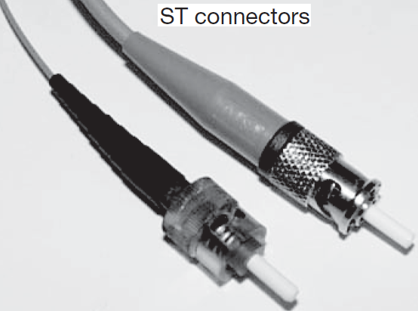
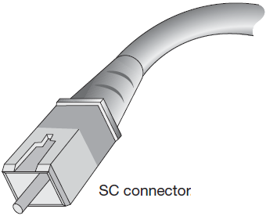
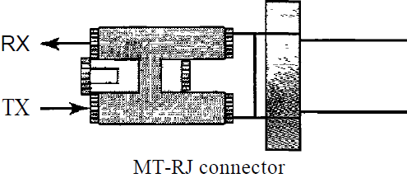

Fiber-optic cable is often found in backbone networks for long distance telecommunication because its wide bandwidth is cost-effective. Some cable TV companies use a combination of optical fiber and coaxial cable, thus creating a hybrid network. Optical fiber provides the backbone structure while coaxial cable provides the connection to the user premises.

Advantages
Fiber-optic cable has several advantages over metallic cable (twisted pair or coaxial).
- Higher bandwidth: Fiber-optic cable can support dramatically higher bandwidths (and hence data rates) than either twisted-pair or coaxial cable. Currently, data rates and bandwidth utilization over fiber-optic cable are limited not by the medium but by the signal generation and reception technology available.
- Less signal attenuation: Fiber-optic transmission distance is significantly greater than that of other guided media. A signal can run for 50 km without requiring regeneration. We need repeaters every 5 km for coaxial or twisted-pair cable.
- Immunity to electromagnetic interference: Electromagnetic noise cannot affect fiber-optic cables.
- Resistance to corrosive materials: Glass is more resistant to corrosive materials than copper.
- Smaller size and lighter weight: Optical fibers are considerably thinner than coaxial cable or bundled twisted-pair cable—at least an order of magnitude thinner for comparable information transmission capacity.
- Greater immunity to tapping: Fiber-optic cables are more immune to tapping than copper cables. Copper cables create antenna effects (i.e. collection of charge mostly seems during IC manufacturing) that can easily be tapped.
- Cheaper and easily available: The optical fibers are made of glass or plastic. The basic material for glass is SiO₂, which is cheaper and plentiful so its production is also cheaper.

Disadvantages
There are some disadvantages in the use of optical fiber.
- Installation and maintenance: Fiber-optic cable is a relatively new technology. Its installation and maintenance require expertise that is not yet available everywhere.
- Unidirectional light propagation: Propagation of light is unidirectional. If we need bidirectional communication, two fibers are needed.
- Cost: The cable and the interfaces are relatively more expensive than those of other guided media. If the demand for bandwidth is not high, often the use of optical fiber cannot be justified.

6.1.2 Unguided (wireless) Transmission Media
Today, people need to be online all the time to exchange the information. For mobile users, twisted pair, coax, and fiber optics are of no use. So, wireless communication is necessary for accessing the data from laptop, notebook, palmtop, etc. without the terrestrial communication infrastructure. Signals are normally broadcast through free space and thus are available to anyone who has a device capable of receiving them.

When electrons move, they create electromagnetic waves that can propagate through space (even in a vacuum). When an antenna of the appropriate size is attached to an electrical circuit, the electromagnetic waves can be broadcast efficiently and received by a receiver some distance away. All wireless communication is based on this principle.

Propagation methods
Unguided signals can travel from the source to destination in several ways: ground propagation, sky propagation, and line-of-sight propagation.
- In ground propagation, radio waves travel through the lowest portion of the atmosphere, hugging the earth. These low-frequency signals emanate in all directions from the transmitting antenna and follow the curvature of the planet. Distance depends on the amount of power in the signal: The greater the power, the greater the distance.
- In sky propagation, higher-frequency radio waves radiate upward into the ionosphere (the layer of atmosphere where particles exist as ions) where they are reflected back to earth. This type of transmission allows for greater distances with lower output power.
- In line-or-sight propagation, very high-frequency signals are transmitted in straight lines directly from antenna to antenna. Antennas must be directional, facing each other and either tall enough or close enough together not to be affected by the curvature of the earth. Line-of-sight propagation is tricky because radio transmissions cannot be completely focused.
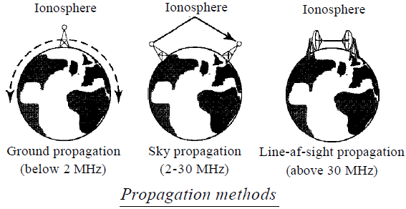

Electromagnetic spectrum
The section of the electromagnetic spectrum defined as radio waves and microwaves is divided into eight ranges, called bands, each regulated by government authorities.
Band | Range | Propagation | Application
VLF (very low frequency) | 3-30 kHz | Ground | Long-range radio navigation
LF (low frequency) | 30-300 kHz | Ground | Radio beacons and  navigational locators
MF (middle frequency) | 300 kHz-3 MHz | Sky | AM radio
HF (high frequency) | 3-30 MHz | Sky | Citizens band (CB) radio,  Ship / aircraft  communication
VHF (very high frequency) | 30-300 MHz | Sky and line-of-sight | VHF TV, FM radio
UHF (ultrahigh frequency) | 300 MHz-3 GHz | Line-of-sight | UHFTV, cellular phones,  paging, satellite
SHF (super high frequency) | 3-30 GHz | Line-of-sight | Satellite communication
EHF (extremely high frequency) | 30-300 GHz | Line-of-sight | Radar, satellite

We can divide wireless transmission into three broad groups: radio waves, microwaves, and infrared waves.
- Radio Waves
The electromagnetic waves ranging in frequencies between 3 kHz and 1 GHz are normally called radio waves. Radio waves are omnidirectional. When an antenna transmits radio waves, they are propagated in all directions. This means that the sending and receiving antennas do not have to be aligned. A sending antenna sends waves that can be received by any receiving antenna. The omnidirectional property has a disadvantage, too. The radio waves transmitted by one antenna are susceptible to interference by another antenna that may send signals using the same frequency or band. The omnidirectional characteristics of radio waves make them useful for multicasting, in which there is one sender but many receivers. AM and FM radio, television, maritime radio, cordless phones, etc. are examples of multicasting.

- Microwaves
Electromagnetic waves having frequencies between 1 and 300 GHz are called microwaves. Microwaves are unidirectional. When an antenna transmits microwave waves, they can be narrowly focused. This means that the sending and receiving antennas need to be aligned. The unidirectional property has an obvious advantage. A pair of antennas can be aligned without interfering with another pair of aligned antennas. The following describes some characteristics of microwave propagation:
- Microwave propagation is line-of-sight. Thus, tower need to be very tall and repeaters are often needed for long distance communication.
- Very high-frequency microwaves cannot penetrate walls. This characteristic can be a disadvantage if receivers are inside buildings.
- The microwave band is relatively wide. Therefore wider sub-bands can be assigned, and a high data rate is possible
- Use of certain portions of the band requires permission from authorities.

Microwaves, due to their unidirectional properties, are very useful when unicast (one-to-one) communication is needed between the sender and the receiver. They are used in cellular phones, satellite networks, and wireless LANs.

- Infrared
Infrared waves, with frequencies from 300 GHz to 400 THz (wavelengths from 1 mm to 770 nm), can be used for short-range communication. Infrared waves, having high frequencies, cannot penetrate walls. This advantageous characteristic prevents interference between one system and another; a short-range communication system in one room cannot be affected by another system in the next room. When we use our infrared remote control, we do not interfere with the use of the remote by our neighbors. However, this same characteristic makes infrared signals useless for long-range communication. In addition, we cannot use infrared waves outside a building because the sun's rays contain infrared waves that can interfere with the communication. Infrared signals can be used for short-range communication in a closed area using line-of-sight propagation.

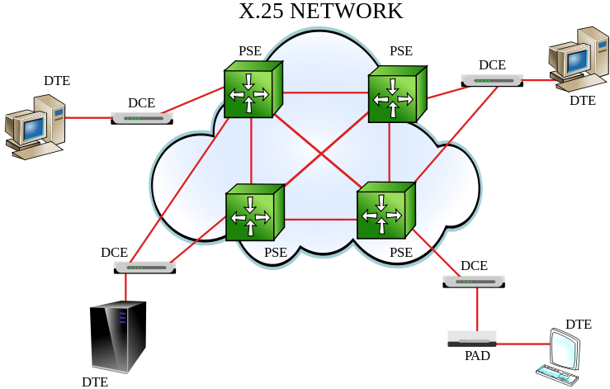
X.25 Network
X.25 is a connected oriented, virtual circuit switching network which was popular in the time of 1970 – 1980, later it was replaced by the frame relay network. The connection must be established first by placing a telephone call. The telephone call was given a certain connection number. The frame for data transmission has 3-byte header & up to 128 byte data. The 3-byte header contains the control information contains: Connection number, Sequence of numbers, ACK number, and Miscellaneous or mixed bits. The X.25 although used in the internet, but it is replaced by other WAN due to the following drawbacks:
    - X.25 has extensive flow & error control at both data link layer & the network layer, which creates an overload and hence slowdown the transmission.
    - The speed is limited to up to 64 Kbps.
    - Originally X.25 was designed for private use, not for internet & has the problem of double overhead.

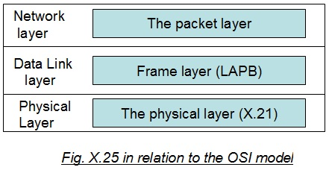
The functionality of X.25 is specified on 3-layers: Physical layer, Frame layer, and Packet layer, which can be seen on figure.
- Physical Layer: In the X.25 technology, physical layer is called X.21 interface. The interface is between DTE & X.25 network.
- Frame layer: At the frame layer, X.25 provides the data link control using a bit oriented protocol called the Link Assess Protocol Balance (LAPB). It transmits the data as a sequence of frame. In the frame layer, communication between DTE & DCE, involves three phases: i) Link setup, ii) Transferring data iii) Link disconnect.
- Packet layer: This layer provides a virtual circuit service. This service enables any subscriber to the network to setup logical connection, called virtual circuits, to other subscribers. Packet layer is responsible for establishing & terminating the connection between two communicating devices. The virtual circuit refers to the logical connection between two stations through the network.
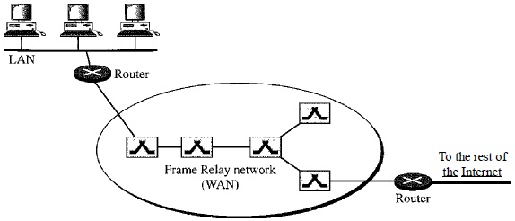
  - Frame Relay
Frame Relay is a virtual-circuit wide-area network that was designed in response to demands for a new type of WAN in the late 1980s and early 1990s. The frame relay network has following features over X.25 and the T-1 & T-3 network.
    - Frame Relay operates at a higher speed (1.544 Mbps and recently 44.376 Mbps).
    - Frame Relay allows bursty data or large data for multiple users.
    - Frame Relay allows a frame size of 9000 bytes, which can accommodate all local area network frame sizes.
    - Frame Relay is less expensive than other traditional WANs.
    - Frame Relay has error detection at the data link layer only (connection oriented network have less error probability) and hence provides fast transmission capability.

Architecture
- Virtual circuit: Frame Relay is a virtual circuit network. A virtual circuit in Frame Relay is identified by a number called a data link connection identifier (DLCI).
- Frame relay provides permanent virtual circuit (PVC) & Switched Virtual Circuit (SVC).
- Switches: Each switch in a Frame Relay network has a table to route frames. The table matches an incoming port-DLCI combination with an outgoing port-DLCI combination.

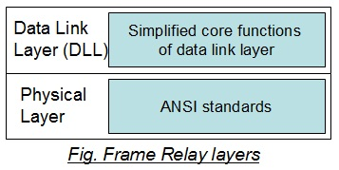
Frame Relay Layers
Frame Relay has only physical and data link layers.
- Physical Layer: Frame Relay supports any of the protocols recognized by ANSI & there is no specific protocol is defined for the physical layer.
- Data Link Layer (DLL): At the data link layer, Frame Relay uses a simple protocol that does not support flow or error control. It only has an error detection mechanism. The address field defines the DLCI as well as some bits used to control congestion.

  - Asynchronous Transfer Mode (ATM) or Call relay
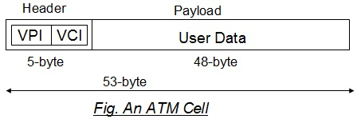
Asynchronous Transfer Mode (ATM) is the cell relay protocol designed by the ATM Forum and adopted by the ITU-T. It is first use by telephony companies to provide voice & data both using either the circuit switching or packet switching. The ATM is a connection oriented network as it is circuit switched network. The connections are virtual or permanent. In permanent connection, one fixed line is assigned permanently so it is possible to transfer the data in any time using this leased line. In virtual connection, the information can transfer by using any line according to their availability.

The ATM makes use of fixed-size cells, consisting of a 5-octet header and a 48-octet information field. There are several advantages to the use of small, fixed-size cells. First, the use of small cells may reduce queuing delay for a high-priority cell, because it waits less if it arrives slightly behind a lower-priority cell that has gained access to a resource (e.g., the transmitter). Second, it appears that fixed-size cells can be switched more efficiently, which is important for the very high data rates of ATM.

The most obvious difference between frame relay and the ATM is that the frame relay uses variable length packets, called frames & ATM uses fixed-sized block of information called Cells. The fixed-sized cell has two advantages of reducing queuing delay and switching more efficiently for high data rate of ATM. ATM can handle real-time transmission with the intended speed of 155 Mbps to 600 Mbps.

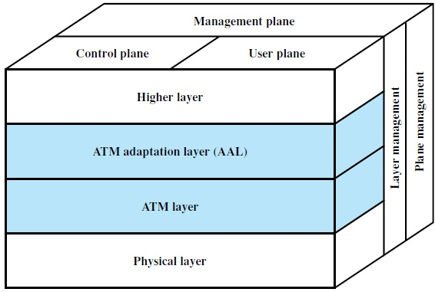
ATM reference model
The ATM standard defines 3 – layers:
- Application Adaptation Layer (AAL) accepts the transmission from upper-layer service & maps them into 48-bit the ATM cells.
- ATM layer provides routing, traffic management, switching & multiplexing services. It processes outgoing traffic by accepting 48-byte segments from the AAL sub-layers and transforming them into 53-byte cells by the addition of a 5-byte header.
- The physical layer defines the transmission medium, bit transmission, encoding & electrical to optical transmission. The original design of ATM was based on SONET (but also support other physical technologies) as the physical layer carrier because it can help to achieve the high data rate & clearly define the boundaries of cells.
- The user plane deals with data transport, flow control, error correction, and other user functions. In contrast, the control plane is concerned with connection management. The layer and plane management functions relate to resource management and interlayer coordination.

  - Public switched telephone network (PSTN)
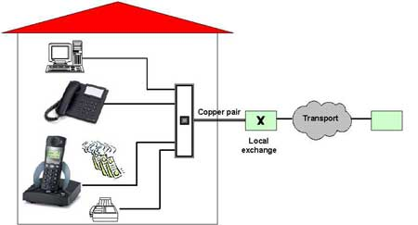
PSTN is the public circuit-switched telephone network that was designed with the goal of transmitting the human voice in a more or less recognizable form. It consists of telephone lines, fiber optic cables, microwave transmission links, cellular networks, communications satellites, and undersea telephone cables, all inter-connected by switching centers, thus allowing any telephone in the world to communicate with any other. Originally a network of fixed-line analog telephone systems, the PSTN is now almost entirely digital in its core and includes mobile as well as fixed telephones.

Soon after Alexander Graham Bell patented the telephone in 1876, there was an enormous demand for his new invention. The initial market, there was a Fully interconnected network where, if a telephone owner wanted to talk to n other telephone owners, separate wires had to be strung to all n houses. Within a year, the cities were covered with wires passing over houses and trees in a wild jumble. Thus, in 1887, the Bell Telephone Company was established and only makes the wire connection from the company to each customer’s house or office. To make a call, the customer would crank the phone to make a ringing sound in the telephone company office to attract the attention of an operator, who would then manually connect the caller to the callee by using a short jumper cable to connect the caller to the callee.
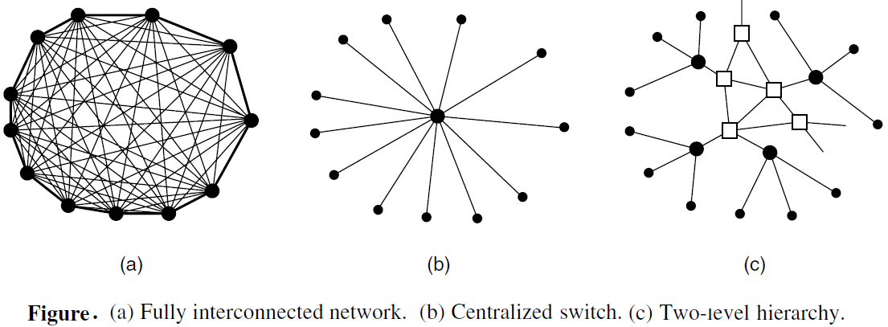

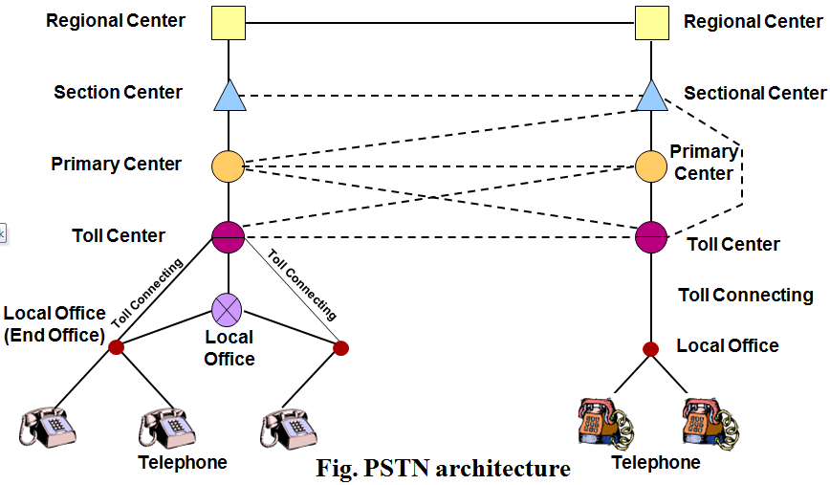
Pretty soon, Bell System switching offices were springing up everywhere and people wanted to make long-distance calls between cities, so the Bell System began to connect the switching offices. The original problem soon returned: to connect every switching office to every other switching office by means of a wire between them quickly became unmanageable, so second-level switching offices were invented. After a while, multiple second-level offices were needed, and then the hierarchy grew to five levels as shown in figure. On growing many changes such as circuit switch, packet switch, digital networks, today we are able to achieve the wireless services with large data rate.

A variety of transmission media are used for telecommunication. Unlike modern office buildings, where the wiring is commonly Category 5, local loops to homes mostly consist of Category 3 twisted pairs, with fiber just starting to appear. Between switching offices, coaxial cables, microwaves, and especially fiber optics are widely used. The connectivity of multiple central, regional and the local offices can be illustrated by the following figure:

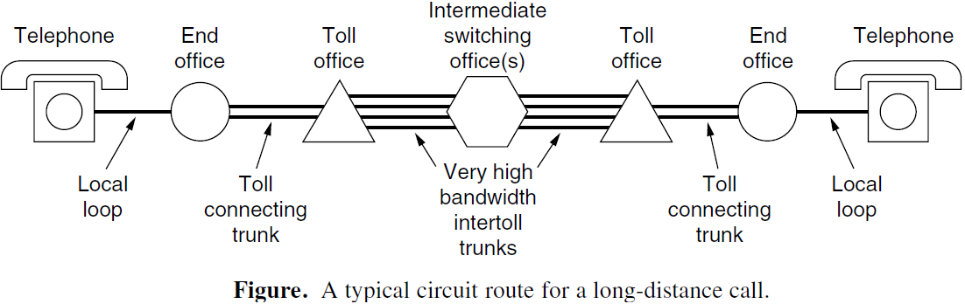

In summary, the telephone system consists of three major components:
- Local loops: analog twisted pairs going to houses and businesses
- Trunks: digital fiber optic links connecting the switching offices
- Switching offices: where calls are moved from one trunk to another

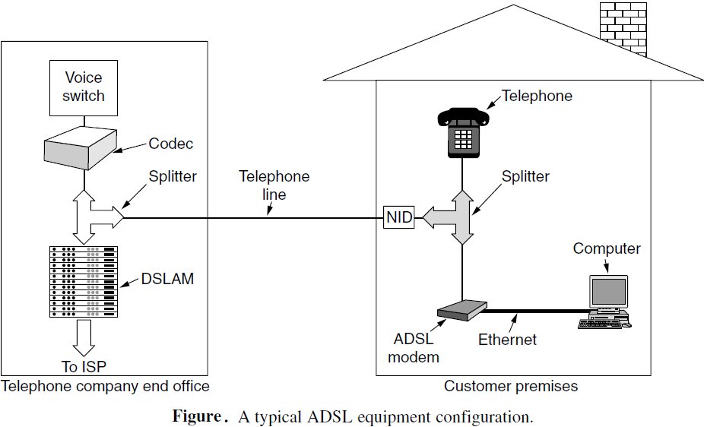
NOTE: ADSL
ADSL (Asymmetric Digital Subscriber Line) is a broadband Internet service that allows an always-on data connection and has the capability of the minimum download speed of 128 kbps up to 2Mbps to an individual PSTN.

- DSLAM: Digital Subscriber Line Access Multiplexer
- NID: Network Interface Device
- Splitter: Separate the voice with low-pass filter and data with high-pass filter

Features:
- Simultaneous availability of Phone and Internet on the existing Telephone line Always on Internet.
- No call charges (dial up) in PSTN line during Internet access.
- 'High on Value Low on Cost' Service
- Telephone line (voice) will continue to work even in case of power failure of CPE (Customer premises equipment) at subscribers end.
- Can share Broadband connection to create own LAN network i.e. more than one PC can be connected

  - Integrated Services Digital Network (ISDN)
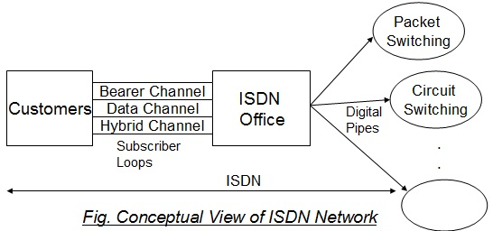
ISDN was developed by ITU-T in 1976. SDN (Integrated Services Digital Network) is a set of protocols and standards that support digital data transmission over the traditional copper PSTN network to deliver higher quality and digitally enabled services. The “integrated” refers to the simultaneous carrying of digitized voice and a variety of data (audio and video) traffic on the same digital transmission links and by the same digital exchanges.

ISDN is a circuit-switched telephone network system, which also provides access to packet switched networks, designed to allow digital transmission of voice and data over ordinary telephone copper wires, resulting in potentially better voice quality than an analog phone can provide. It offers circuit-switched connections (for either voice or data), and packet-switched connections (for data). The basic principles of ISDN are:
- Support of voice and non-voice applications using a limited set of standardized facilities
- Support for switched (both circuit-switched and packet-switched connections) and non-switched applications (dedicated lined)
- Reliance on 64-kbps connections because it was the standard rate for digitized voice
- Intelligence in the network switching
- Layered protocol architecture that can be mapped to OSI model
- More than one physical configuration is possible for implementing ISDN
- More suitable to handle different types of services (voice, data and video)
- As a digital technology, ISDN enables more error control and flow control mechanisms

The goal of ISDN is to form a WAN that provides universal end-to-end connectivity over digital media. This can be done by integrating all of the separate transmission services into one without adding new links or subscriber lines. Unlike the traditional analogue PSTN services, ISDN as a digital technology has the many technical advantages as mentioned on its feature. Frame format is very similar to that of HDLC
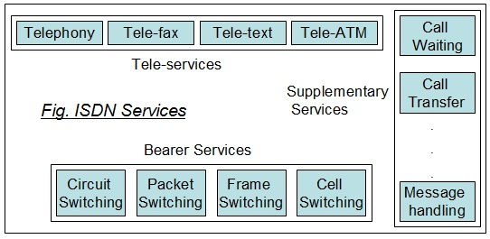
ISDN Services
The purpose of the ISDN is to provide fully integrated digital services to users. The services fall into three categories:
- Bearer Services
- Tele-Services &
- Supplementary Services

- Bearer Services
  - Provides the means to transfer information (Voice, data, & Video) between users without network manipulating the content of that information.
  - Bearer services belong to the first three layers of OSI model & are well defined in the ISDN standard. They can be provided using circuit switched, packet switched, and frame switched etc. networks.
- Tele-Services
- In tele-servicing, the network may change or process the contents of data. These services correspond to layer 4 to 7 of the OSI model.
- Tele-services relay on the facility of the bearer services and are designed to accommodate complex user’s needs without the user having to be aware of the details of the process. Tele-services include telephony, tele-fax, telex, videotext, & tele-conferencing.
- Supplementary Services
- Supplementary services are those services that provide additional functionality to the bearer services & tele-services. Examples of these services are the reverse charging, call waiting, message handling etc.

Conceptual View of ISDN network
The figure shows the conceptual view of the connection between the users and the ISDN central office. Each user is linked to central office through digital pipes which has different capacity to allow different rate of transmission & support different subscriber’s needs. To allow flexibility between the customers & the central office, the digital pipes are organized into multiple channel types, each with different transmission rate i.e. Bearer (B) channel (64 Kbps), Data (D) channel (16Kbps or 64Kbps), Hybrid (H) channel (384Kbps, 1536Kbps, or 1920Kbps). The digital subscriber loops (digital pipes) are of two types:
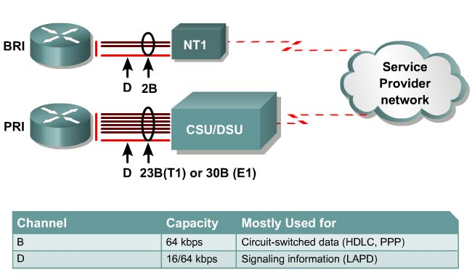
    - Basic rate interface (BRI): It consists of 3B channels & one 16 Kbps D-channel. Hence 2-persons can communicate at a time.
    - Primary rate interface (PRI): It consists of 23B channels & 64 Kbps D-channel so at a time up to 23 people can simultaneously communicate to each other.

